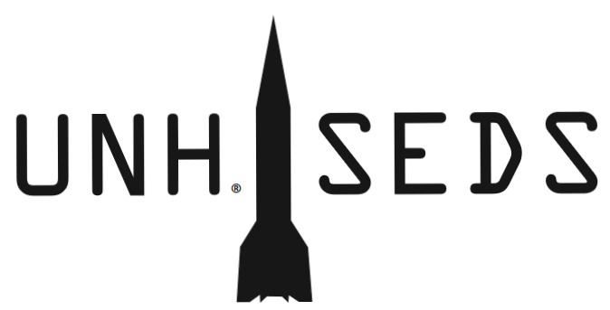

Dear CEPS Department Chairs,

UNH SEDS (Students for the Exploration and Development of Space) has launched 8 rockets in the past few months; each an iteration and improvement on the previous design. We began with a single engine rocket and have since moved to two stages (two engines). Using a GPS and an altimeter in our electronics bay, we have been working towards successfully recovering each rocket stage and bringing all components to the ground safely via parachute. Our electronics record flight data from each launch, which we have compared to MATLAB and Open Rocket trajectory simulations. We started our builds with cardboard tubing, then switched to blue tube (commonly used model rocketry material), and now plan to manufacture a carbon fiber rocket for the final competition. Our most recent build was a prototype for the carbon fiber rocket; the major difference being it was made of blue tube.

SEDS participated in the URC this year and placed second among the ME competition teams (receiving honorable mention). Judges were impressed by our presentation, poster, and overall progress we have made in such short time. We began as a group of individuals from various academic backgrounds with no previous rocketry experience or skills. Not only have we all learned so much over the course of the year from failures, successes, and each other, but we have also expanded into more than just a senior project. Students from all across CEPS in multiple engineering departments, ranging from freshman to seniors, have become involved with the organization. We have taught underclassmen basic rocket theory and principles and allowed each of them to help with rocket manufacturing. As we fly more complex rocket builds, more students, both inside and outside of the organization, are attending the launches.

Moving forward, we still need to manufacture our final competition rocket. Unlike most competition teams, our competition is in October. This will require several engines and numerous carbon fiber and blue tube materials. We have stretched money we were given to start this project for as long as possible and have now all but run out. For the organization to move forward we will need additional funding. Considering the success and rapid development and expanse of UNH SEDS, we hope that you can help. You are being contacted because students from your department play an active role in the organization.

Please see the attached files for our active member information, current financial status, and upcoming purchases that need to be made.

Respectfully,

Charlie Nitschelm

UNH Class of 2020

Mechanical Engineering